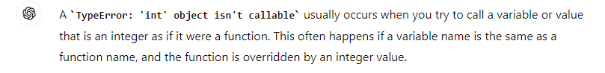

The error in the program is here.

I use move_forward as a function here

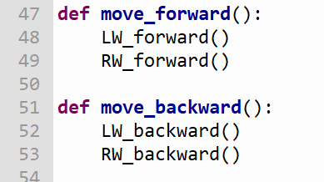

and move_forward as a variable here as well.

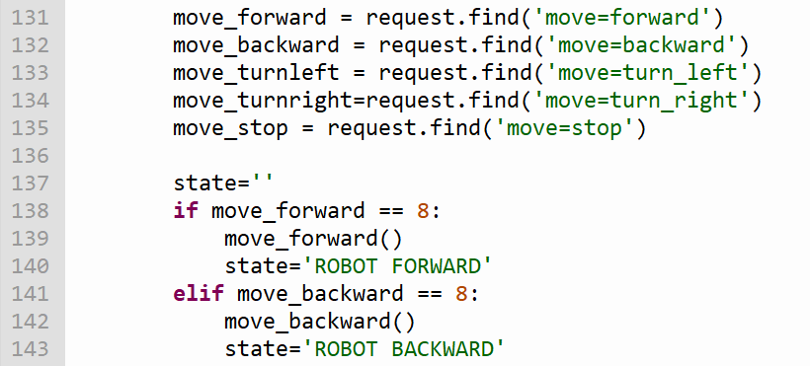

When we use turn_right() or turn_left() – move_forward as variable and move_forward() as function gets confused. Hence the error

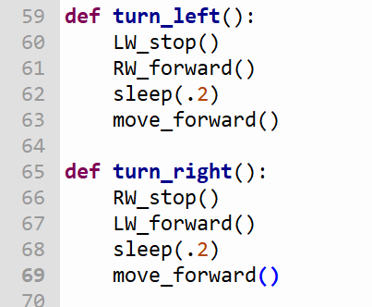

I suggest we change all the move_ functions from line 131 to line 135 to action_

